**DIET MANAGEMENT EXPERT SYSTEM**

**TEAM – 2**

**HARITHA SRINIVASAN**

**BHAVANI MALLAVALLI**

**SINDHURA BYREDDY**

**PROJECT BACKGROUND :**

This decision support system will assist a person to maintain or keep tract of his/her diet requirements. It helps a person to maintain a proper diet and reach their personal goal. It also gives a clear picture on how to remain health conscious as the system suggests the food requirements for the person. It helps a person to maintain a proper diet and reach their personal goal. It also gives a clear picture on how to remain health conscious as the system suggests the food requirements for the person.

**IMPACT OF DECISION MAKING IN THIS SCENARIO:**

1. **BMI**: In this system, the person’s body mass index is necessarily important for the system to suggest an apt diet.
2. **MEDICAL HISTORY**: Based on the person’s medical history the necessary food can be filtered for the person from which he/she can choose.
3. **CALORIE INTAKE**: The calorie intake depends upon the personal goal of the person and the BMI , based on which the system can suggest the type of food needed.

**INPUTS /DATA SOURCES:**

1. It needs the user to input the height in terms on feet and inches.
2. Weight of the person
3. Medical history:

A set of user interactive questions that the user needs to input for the system to provide alternative suggestions.

1. Personal Goal :

The user needs to specify his/her personal goal for example, to specify (slim, fit, gain weight etc.)

1. Choice of food :

The user needs to input the/her food interest based on the system’s suggestion considering the calorie scale.

1. Database support is included: Tables required to store the food categories based on the individual health information.

The Architecture of DSS :

This application can be composed of a data management subsystem, a model management subsystem, a user interface and a knowledge based management system.

**DATA COMPONENT – The data management subsystem**

The data management subsystem includes a database that contains various special datasets which are managed by SQL-SERVER Database Management Systems.

**TABLES:**

DMFoodCategory(Category ID(PK), Category_Name)

DMFoodCalorie (Food_ID(PK), Food_Name, Category_ID(FK),Food_Quantity)

DMUser (User_ID(PK),User_Name,Password)

DMHeartDisease (HDFood_ID (PK),Disease_ID(FK),Food_ID(FK))

DMHighBP (HTFood_ID(PK),Disease_ID(FK),Food_ID(FK))

DMDiabetes (DFood_ID(PK),Disease_ID(FK),Food_ID(FK))

DMDisease (Disease_ID(PK),Disease_Name)

**MODEL COMPONENT –** in this part of subsystem we need to use a model to calculate BMI (Body Mass Index) which play a vital role to access data from data component, based on user requirement we will project calculated diet and fitness required by the user. We may also help user with suggestion to choose various type of food and physical exercises need to be done to maintain a proper health.

|  |  |  |
| --- | --- | --- |
| BMI = ( | Weight in Pounds              (Height in inches) x (Height in inches) | ) x 703 |

Since this application is intended to give satisfied results to end user we are likely to get all details needed and provide results based on user requirements. Say if user is slim and interested to become muscular the system will suggest him with the best food he needs to consume. We use above formula to calculate BMI and above medical value chart for the purpose of this application. And based on those results DATA from data component is collected and projected in front of USER.

This model falls under **Predictive models category**, since we have only few values to get a better result among very few number of alternatives and using this alternatives and pre calculated values.

**KNOWLEDGE COMPONENT:** This part of application uses expert Knowledge such as food nutrition information, User health related information, and General food exemption based on diseases user is diagnosing for. This application also get health related information form user to suggest healthy food user needs to take even when user is diagnosing with some medical illness.

**ER-DIAGRAM :**

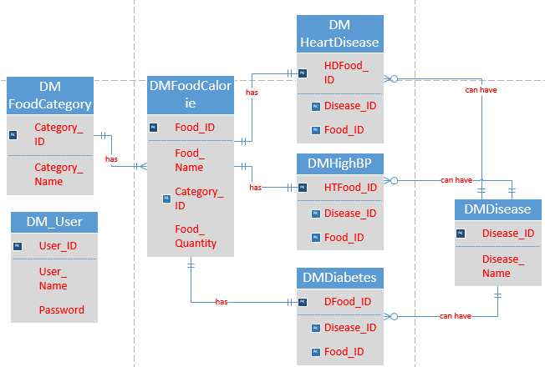

**SOFTWARE FEATURE REQUIREMENTS:**

**TECHNOLOGIES USED:**

FRONT END: ASP.NET

BACK END: SQL SERVER

**LOGIN :**

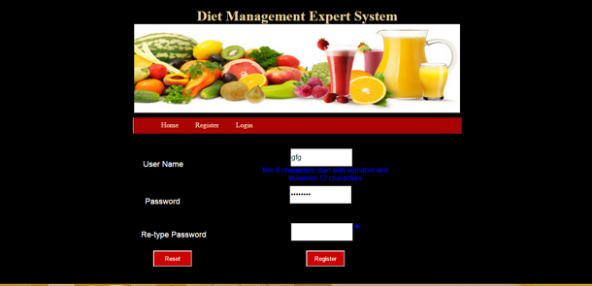

**DATA VALIDATION:**

1. Minimum of 6 characters and should start with alphabets and maximum 12 characters.
2. For data validation we used regular expression for our project.
3. If the user registers with an existing name, the system tells the user to a new name.
4. Reset button enables the user to clear all the contents.

**DATABASE CONNECTION:**

We have used SQLOLEDB for the database connectivity. The front end used is the Microsoft Visual Studio that is the Asp.net and Sql server at the back end

**HOW TO RUN THE SYSTEM:**

Deploy database:

1. Go to SQL Server Management Studio
2. Create a Database with Diet Management
3. Paste Diet_Management.bak in C:\Program Files\Microsoft SQL Server\MSSQL11.MSSQLSERVER\MSSQL\Backup
4. Right click on Diet_Management->Tasks->Restore->database->fromdevice->add->location of backup(and select db. backup file)
5. Then press OK select file (in checkbox) go to options
6. Select overwrite the existing database (check box)

To run the project:

1. Need to open Microsoft Visual Studio Solution (.sln) file of Diet_Management
2. Open the Home.aspx page
3. Click on Build solution
4. Click on Start Debugging

**RESULT:**

The result should display the food suggestions for the user based on the diseases and the medical history recorded. The system also displays the calories the user needs to consume for his/her diet.

The following screenshots show the working of the decision support system

SCREENSHOT 1:

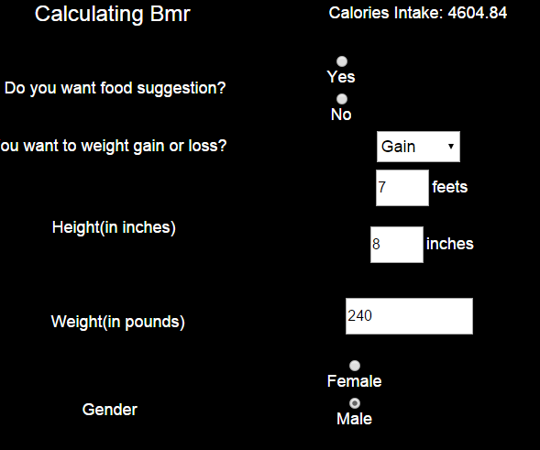

SCREENSHOT2:

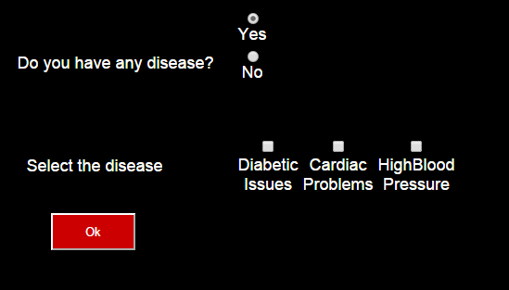

SCREENSHOT 3:

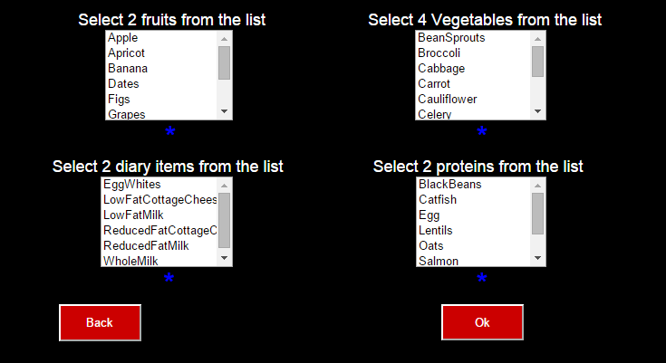

FINAL OUTPUT:

